[VGS(off) for JFET in AGC circuit](https://electronics.stackexchange.com/questions/334533/vgsoff-for-jfet-in-agc-circuit)

[Ask Question](https://electronics.stackexchange.com/questions/ask)

0

I want to use a well known AGC circuit (see below) with 3.3V instead of 5V. The description of the circuit can be found [here](http://www.electronicdesign.com/analog/effective-agc-amplifier-can-be-built-nominal-cost), and state the following about the JFET:

Other JFETs with VGS(OFF) of 5V or under, such as the 2N5019 or 2N5116, should work equally well in this circuit, although they haven’t been tried. To use JFETs with higher VGS(OFF), such as the 2N3993 (it was tried and worked equally well), increase the supply voltage to 12 V.

Can I still use the [J176](https://www.fairchildsemi.com/datasheets/MM/MMBFJ175.pdf) when the supply voltage is 3.3V, or do I need to select a different JFET?

[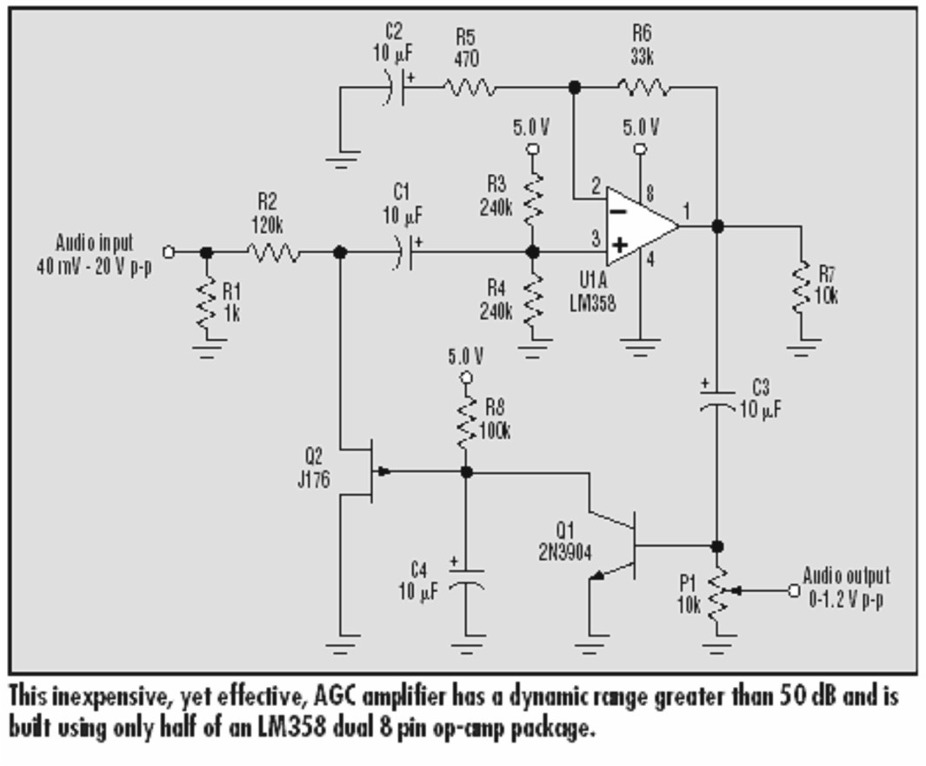](https://i.stack.imgur.com/bHg0K.jpg)

[transistors](https://electronics.stackexchange.com/questions/tagged/transistors) [3.3v](https://electronics.stackexchange.com/questions/tagged/3.3v) [jfet](https://electronics.stackexchange.com/questions/tagged/jfet" \o "show questions tagged 'jfet')

[share](https://electronics.stackexchange.com/q/334533)[improve this question](https://electronics.stackexchange.com/posts/334533/edit)

asked Oct 15 '17 at 12:42

[[https://www.gravatar.com/avatar/a22f1fd935abc75accddaa43e19dc0ec?s=32&d=identicon&r=PG&f=1](https://electronics.stackexchange.com/users/128364/johndonut)](https://electronics.stackexchange.com/users/128364/johndonut)

[JohnDonut](https://electronics.stackexchange.com/users/128364/johndonut)

**56**4

* Be aware that pinch-off gate voltage for almost any FET has a notoriously wide range. For J176, data sheet suggests 1 - 4 volt range. So some may not have a wide AGC range with a 3.3V supply. – [glen_geek](https://electronics.stackexchange.com/users/122656/glen-geek" \o "9,766 reputation) [Oct 15 '17 at 13:37](https://electronics.stackexchange.com/questions/334533/vgsoff-for-jfet-in-agc-circuit#comment787501_334533)
* Sorry, but I am a novice when it comes to these things. So using the J176 with 3.3V will not give me an AGC for 40mV to 20V? Would it be better to supply LM358 with 12V and use one of the suggested JFETS instead? – [JohnDonut](https://electronics.stackexchange.com/users/128364/johndonut" \o "56 reputation) [Oct 15 '17 at 16:21](https://electronics.stackexchange.com/questions/334533/vgsoff-for-jfet-in-agc-circuit#comment787559_334533)
* 1

LM358 with 3.3V supply is *very* close to its minimum. Certainly, a higher DC supply will help both LM358, and the FET AGC range. If you *must* use 3.3V supply, a J177 would be suitable. Some, perhaps most J176 would be OK while a few (whose pinch-off is near 4V) would have poorer AGC range. – [glen_geek](https://electronics.stackexchange.com/users/122656/glen-geek" \o "9,766 reputation) [Oct 15 '17 at 18:16](https://electronics.stackexchange.com/questions/334533/vgsoff-for-jfet-in-agc-circuit#comment787595_334533)

* @glen_geek Thanks! That's all I wanted to know. If you add an answer with the same information, I will mark it as accepted. – [JohnDonut](https://electronics.stackexchange.com/users/128364/johndonut" \o "56 reputation) [Oct 16 '17 at 9:26](https://electronics.stackexchange.com/questions/334533/vgsoff-for-jfet-in-agc-circuit#comment787804_334533)

！！！！！！！！！！！！！！！！！！！！！！！！

# Circuit provides 70 dB of AGC

Ben Segal, Telecommunications Technology, Sunnyvale, CA; Edited by Margery Conner and Fran Granville -February 02, 2012

[**1 Comments**](https://www.edn.com/design/analog/4368939/Circuit-provides-70-dB-of-AGC#comments)

Share

[Save Follow](https://www.edn.com/design/analog/4368939/Circuit-provides-70-dB-of-AGC)PRINT[PDF](https://www.edn.com/Pdf/ViewPdf?contentItemId=4368939)[EMAIL](mailto:?subject=Circuit%20provides%2070%20dB%20of%20AGC&body=https://www.edn.com/design/analog/4368939/Circuit-provides-70-dB-of-AGC)

|  |
| --- |
| [**Click here to download a PDF**](https://m.eet.com/media/1156530/2-2%20design%20ideas.pdf) |
|  |

**[Design Ideas Classics](http://www.edn.com/designideas)**  
**Originally published in the May 5, 1979, issue of EDN**

**[](https://www.edn.com/common/jumplink.php?target=http%3A%2F%2Fbit.ly%2FDesignIdeasClassics)**The circuit diagrammed in the **figure** provides a 70-dB automatic-gain-control range for input voltages of −60 to +10 dBm over a bandwidth of 55 Hz to 15 kHz. The worst-case distortion is 3%, but distortion typically measures less than 1% in the 100-Hz to 10-kHz range.

The signal autoranges to keep the input to the AGC section between −60 and −25 dBm; this procedure allows the FET to operate in its most linear region. A comparator performs the autoranging, comparing a −25-dBm reference with the signal from A1 and A2. A4furnishes the AGC action, settling a −15-dBm output as a reference voltage; A5 provides a fixed 15-dB gainand an output of 0 dBm. A6, A7, and the FET constitute the AGC’s feedback circuit.

**[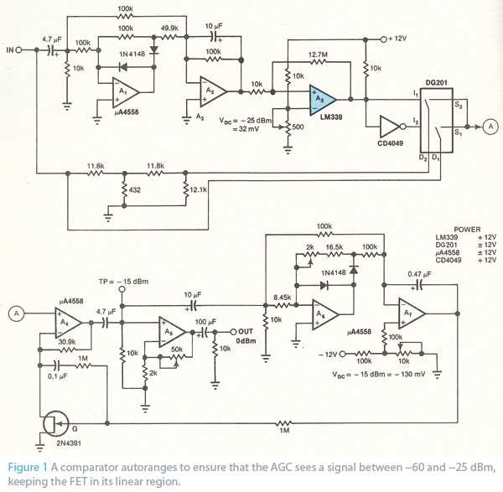](http://www.edn.com/photo/295/295781-Circuit_provides_70_dB_of_AGC_figure_1_enlarged.jpg)**

@@@@@@@@@@@@@@@

[Home](https://www.electroschematics.com/) / Automatic Gain Control – AGC Circuit

[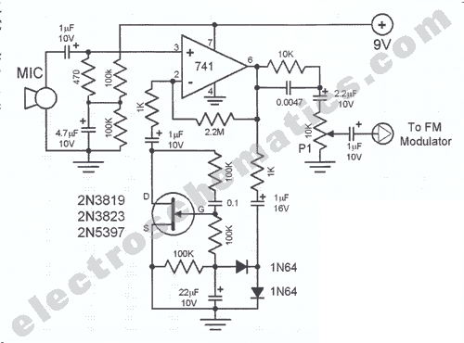](https://www.electroschematics.com/wp-content/uploads/2009/09/mic-preamp-agc.gif)

# Automatic Gain Control – AGC Circuit

[RECEIVED BY EMAIL](https://www.electroschematics.com/author/email/)

[](https://www.facebook.com/sharer/sharer.php?u=https://www.electroschematics.com/248/automatic-gain-control-agc/) [[](https://twitter.com/share)](https://twitter.com/share)[https://www.electroschematics.com/wp-content/themes/electroschematics-v2/img/icn-question-orb.png](https://www.electroschematics.com/qa/)

* [741](https://www.electroschematics.com/tag/741-circuits)
* [AGC](https://www.electroschematics.com/tag/agc-circuits)

Automatic Gain Control or AGC is a circuit design which maintain the same level of amplification for sound or radio frequency. If the signal is too low the AGC circuit will increase (amplify) the level and if is to high will lower it to maintain a constant level as possible. The Automatic Gain Control principle is widely use in AM receivers and sometimes AGC is called an compressor-expander because it acts just like one.  
  
On the electroschematics.com site you can find some AGC schematics, just use the seach box.

## Mic preamplifier with AGC schematic

**[](https://www.electroschematics.com/wp-content/uploads/2009/09/mic-preamp-agc.gif)**

@@@@@@@@@@@@@@@@@@